## Web Development

Internship Report submitted in partial fulfillment of the requirement for the award of the degree of

**BACHELOR OF TECHNOLOGY IN**

**COMPUTER SCIENCE AND ENGINEERING**

By

**A Naga Harshini 20R11A0563**



**Department of Computer Science and Engineering**

**Accredited by NBA**

#### Geethanjali College of Engineering and Technology

**(UGC Autonomous)**

(Affiliated to J.N.T.U.H, Approved by AICTE, New Delhi) Cheeryal (V), Keesara (M), Medchal.Dist.-501 301.

**August-2022**

i

# Geethanjali College of Engineering & Technology

**(UGC Autonomous)**

(Affiliated to JNTUH, Approved by AICTE, New Delhi) Cheeryal (V), Keesara(M), Medchal Dist.-501 301.

**DEPARTMENT OF COMPUTER SCIENCE AND ENGINEERING**

**Accredited by NBA**



**CERTIFICATE**

This is to certify that the Internship Report entitled **“WEB DEVELOPMENT”** is a bonafide work done by **A NAGA HARSHINI(20R11A0563)** in partial fulfillment of the requirement of the award for the degree of Bachelor of Technology in “**Computer Science and Engineering**” from Jawaharlal Nehru Technological University, Hyderabad during the year 2021-2022.

**HOD - CSE**

**Dr. A Sree Lakshmi Professor**

Examiner Name:

Designation:

Internship Certificate



# Geethanjali College of Engineering & Technology

**(UGC Autonomous)**

(Affiliated to JNTUH Approved by AICTE, New Delhi) Cheeryal (V), Keesara(M), Medchal Dist.-501 301.

**DEPARTMENT OF COMPUTER SCIENCE AND ENGINEERING**

**Accredited by NBA**



**DECLARATION BY THE CANDIDATE**

I, **A Naga Harshini**, bearing Roll No. **20R11A0563**, hereby declare that the Internship Report entitled **“Web Development”** is submitted in partial fulfillment of the requirements for the award of the degree of **Bachelor of Technology in Computer Science and Engineering**.

This is a record of bonafide work carried out by me in **Kaashiv Infotech** and the results

embodied in this internship have not been reproduced or copied from any source. The results embodied in this Internship Report have not been submitted to any other University or Institute for the award of any other degree or diploma.

**A Naga Harshini,20R11A0563 Department of CSE,**

**Geethanjali College of Engineering and Technolgy,Cheeryal.**

**ACKNOWLEDGEMENT**

**I want to express my gratitude to KAASHIV Infotech for providing me with the chance to do an internship with the company. Additionally, I want to express my gratitude to everyone who cooperated with me by being open-minded and patient. It is in fact with an enormous sense of joy and I am grateful that I am able to acknowledge their assistance.I owe Principal Dr. Udaya Kumar Susarla a huge debt of gratitude for the services he gave to finish the internship. I want to express my gratitude to Dr. A. Sree Lakshmi's, the department head.For all of her helpful critiques during my internship. I would also like to express my sincere gratitude to Venkateshan Prabu, who served as my mentor, for his crucial suggestions and help with finishing my internship. He was there to help me at every stage, and it was his drive that made it possible for me to complete my assignment successfully. I also want to express my gratitude to all the other support staff members who helped me by providing the tools I needed to complete this project successfully. Without their help, I would not been able to complete my internship.**

Introduction about Internship Organization

##### Kaashiv Infotech

Kaashiv info tech has provided specialized Knowledge Services to a wide range of industry verticals. This puts us in a unique position where we are able to not only deliver cutting edge solutions but also help build in-house competencies of our Clients, be it in the Knowledge Services domain or a part of our Enterprise Services.

* ISO Certified Company – Google Rated Number 1
* **Common Wealth Bank** Recognized Leading Light Rising Star Award Winner
* Run by 10 Years **Microsoft Awarded MVP (** Most Valuable Professional )
* **Google** Recognized Experts
* **Cisco** Recognized Certified Experts
* **Microsoft** Certified Professionals
* **Artificial Intelligence** and Robotics Experts
* **HCL Technologies** Awarded **SME** ( Subject Matter Expert )

Kaashiv InfoTech Trainers are real-time Electronics experts and professionals worked in leading MNCs like HCL,TCS,Infosys,Cognizant,Wipro.

It has 13 years of experience company,25 professional experts.

### TRAINING SCHEDULE

|  |  |  |
| --- | --- | --- |
| Module Number | Module Name | Time Allocated |
| Module 1 | HTML Basics (Tags,tables,Links,Images) | 2 days |
| Module 2 | HTML  Frames,blocks,backgrounds,forms,layouts | 5 days |
| Module 3 | CSS Introduction,padding ,margins | 3 days |
| Module 4 | Document Object Model(DOM) | 2 days |
| Module 5 | Javascript functions,events,form validation | 5 days |
| Module 6 | Bootstrap | 3 days |
| Module 7 | Git and GitHub and project | 10 days |

TABLE OF CONTENTS

|  |  |  |
| --- | --- | --- |
| S.NO | Contents | Page No |
| 1 | Abstract | 1 |
| 2 | List of figures | 03 |
| 3 | List of screenshots | 04 |
| 4 | Introduction | 02 |
| 5 | Related work/ Technologies used | 09 |
| 6 | Work done/ Observation/ Duties performed | 11 |
| 7 | Learning after Internship | 12 |
| 8 | Summary / Conclusion | 13 |
| 9 | Bibliography | 13 |

### ABSTRACT

Every step in the current world is automated, from purchasing everyday items to purchasing expensive technology goods. Local business owners must now elevate their business strategies by including digitalization and e-marketing into their plans in order to survive the current entrepreneur competition. In order to give the client/customer the most dependable and convenient service, they must offer door-step service. Designing websites and education the primary goal of this internship was HTML. Numerous programming languages are used to create web-based applications. Some of them are just utilised for the software's frontend and backend design. HTML3, HTML4, HTML5, CSS, Bootstrap, JavaScript, etc. are a few examples. There are now some frameworks that are widely used. Frameworks use Model, View, and Controller to implement structured programming. MVC is another name for it. The ability to access a web-based application from anywhere in the world makes it highly handy for us. For our everyday lives, it is quite useful.

### Introduction

The goal of this project is to create a general-purpose online store where consumers can shop for products like clothing,gym wear from their homes. A virtual store on the Internet where customers can peruse the catalogue is known as an online store. In this web application User is only able to browse the online shop and add a product to the cart. The user is limited to the use of the shop. E-commerce is fast gaining ground as an accepted and used business paradigm. More and more business houses are implementing web sites providing functionality for performing commercial transactions over the web. It is reasonable to say that the process of shopping on the web is becoming commonplace.

The project ecommerce website is developed only using front end technologies –HTML for implementing structure,CSS-for presentation,Javascript for providing functionality .

* 1. Description
     + Any member can register and view available products.
     + Only respective subscribers can avail benefits.

2

### Figures

Mainpage.

html

Aboutus.

html

Subscripti

on.html

1

Aboutu

s.css

Indoor.h

tml

Outdoor.

html

Subscri

ptions.

css

Indoor.cs s

Outdoor. css

Mainpa ge.css

3

Screenshots

##### 1)Main Page



1)

M 2)About us page

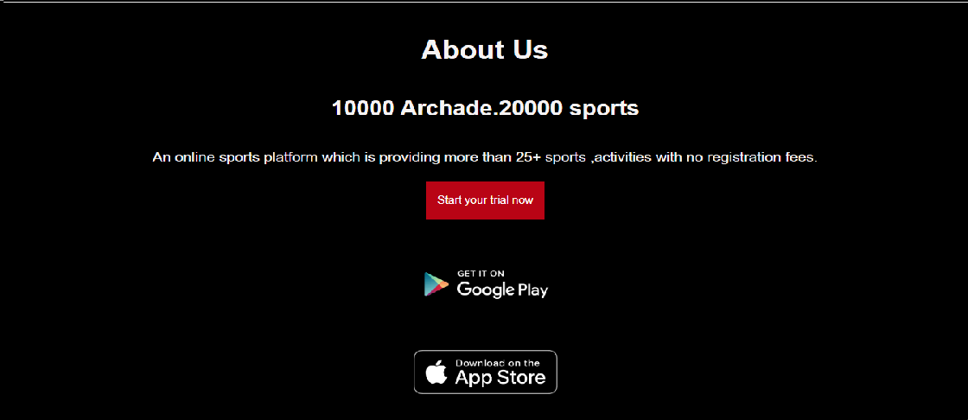

4

##### After selection of start your free trial button

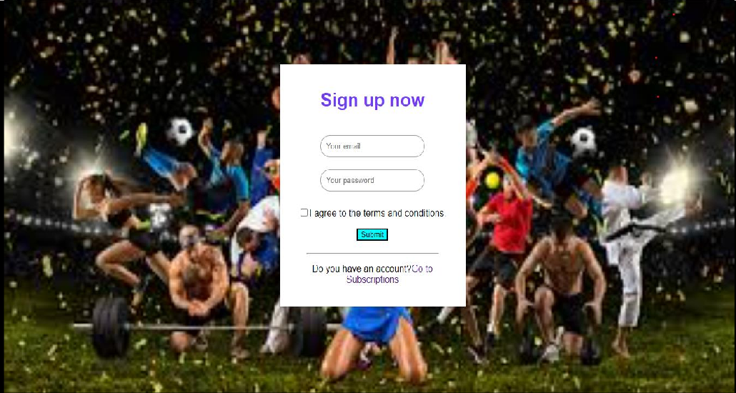

A

Valid message pops up for correct credentials

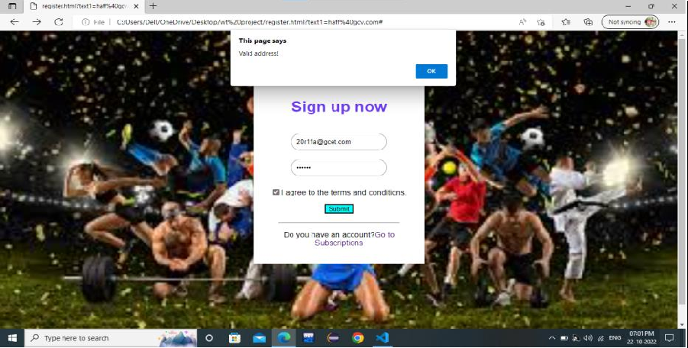

55

5

Invalid message gets displayed for wrong email address

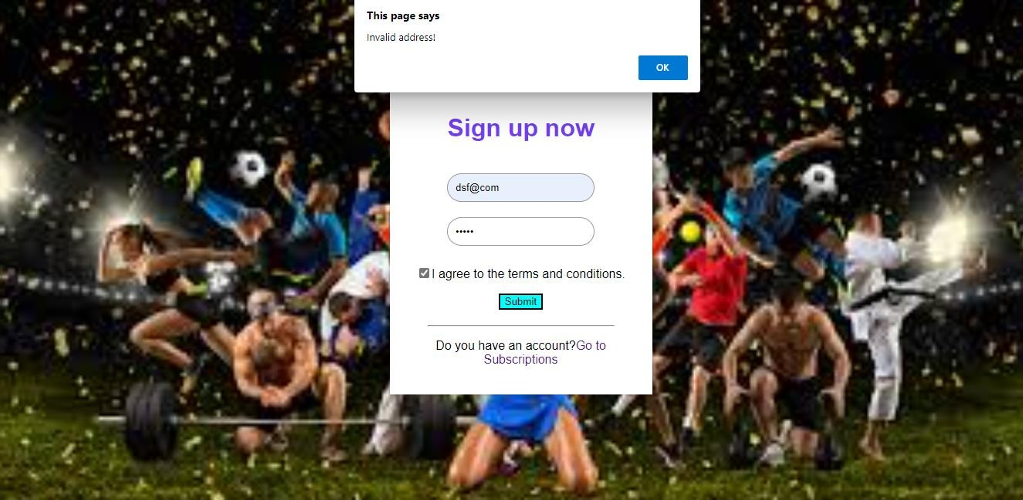

4

### Indoor Page

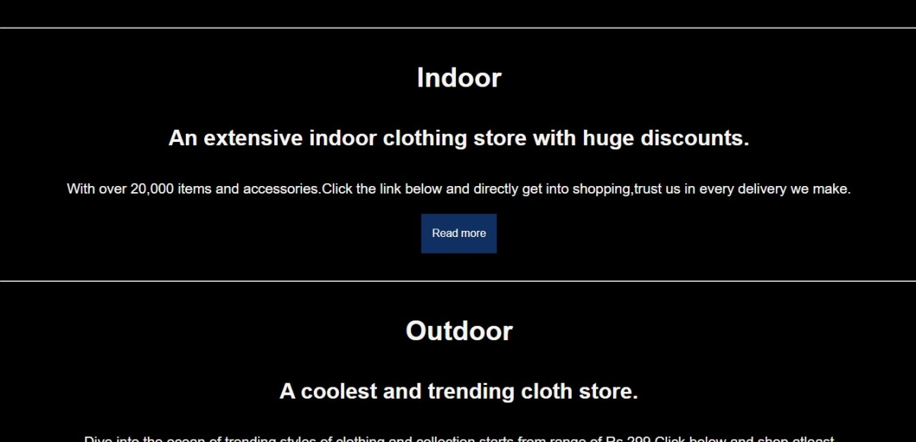

1. Outdoor Page

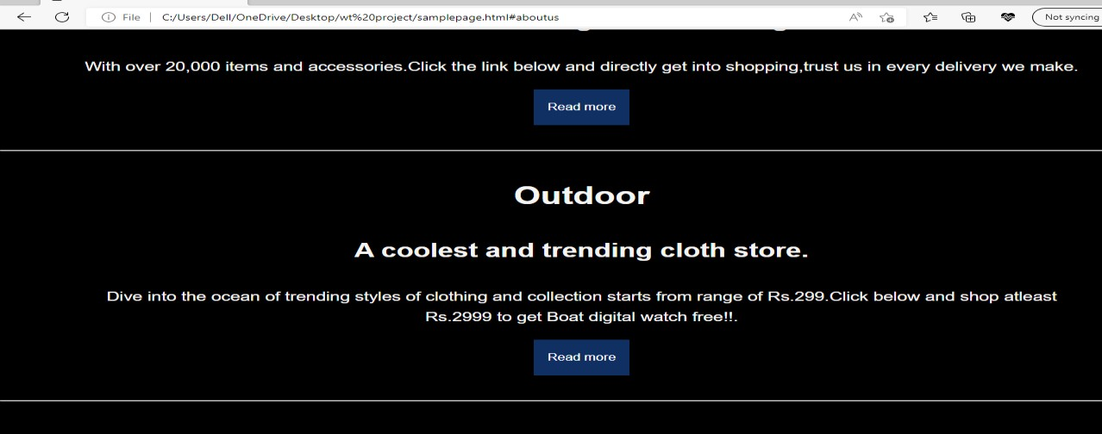

### Outdoor shopping cart

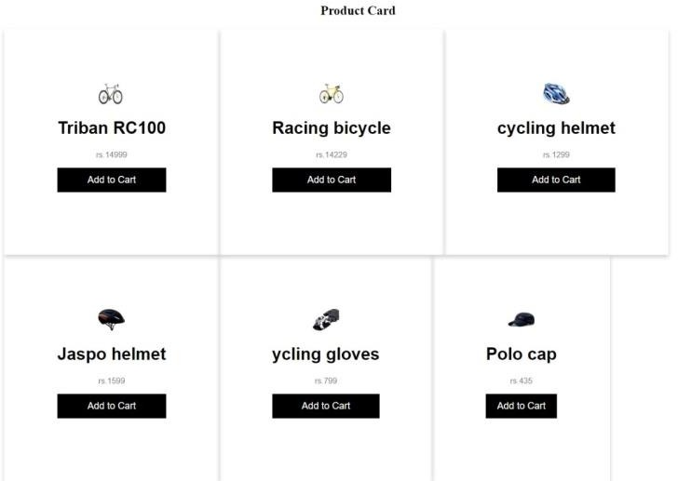

7

### Subscription page



1. Main page footer

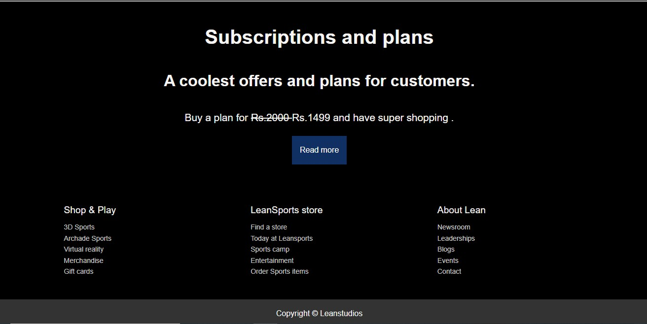

### Related Work/Technologies used

These are the resources and tools required to construct the website, and the project is only front-end built. Open source content and software are some of them.

##### HTML

* + - Hypertext Markup Language is known as HTML. Web pages are written in this language. Additionally, this language facilitates the development of interactive and responsive web pages using other languages like CSS, PHP, and JavaScript. Simply put, HTML5 is an improved version of HTML. It supports new functions, new HTML elements, new attributes, full CSS3 support, video and audio, and 2D/3D graphics that benefit users and make it simpler for web designers to add new functions to thewebsite.Hypertext. is the way by which we travel across the web by clicking hyperlinks – specific texts taking you to other pages. Hyper means it’s non- linear, which allows for moving to any other place, as there is no predefined order to do so.
    - tThe markup deterrmines the qualities that HTML tags apply to the text inside them. Tags mark it as a particular type of text.
    - As a language, it holds code words and syntax like any other language.

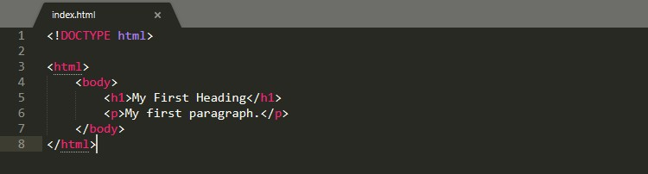

##### Cascading Style Sheets

Style sheet languages included in project is CSS (or Cascading Style Sheets). It is used to provide the design, layout, and variants for various devices with various screen sizes when displaying HTML elements on a webpage. At one time, CSS may handle the layout of many separate web pages.

CSS makes use of selectors to connect with HTML. The section of CSS code known as a selector determines which HTML element will be affected by CSS styling.

The selector uses the attributes and values that are contained in a declaration.

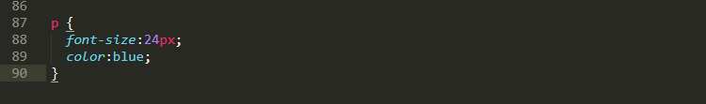

Here P (for paragraph) is selector, { font-size:24px; color:blue; } is a declaration, font- size: and color: are properties, while 24px; and blue; are values.

##### CSS Framework-Bootstrap

A CSS framework is a set of predefined CSS and HTML files. It extends a front-end developer’s skills for website design. CSS frameworks offer distinct and symmetrical layouts in addition to aiding in the creation of a responsive design, preventing developers from having to start writing code from scratch on every occasion.

footer .footer-cols{

display:grid; grid-gap:20px;

grid-template-columns:repeat(3,1fr); padding:2rem;

text-align:left; text-decoration:none;

font-size:14px;

This is developed as footer in the project.

Developers only need to place the code into a pre-defined grid system because Bootstrap is a framework that already includes the fundamentals for developing responsive websites.

Hypertext Markup Language (HTML), cascading style sheets (CSS), and JavaScript serve as the foundation for the Bootstrap framework.Subscription module of project is developed using this .

##### Javascript

One of the most widely used scripting languages is avaScript (JS). The main reason for its fame is that it offers a complete stack of technologies for front-end and back-end development. As long as we're talking about the first one, dynamic web pages are created using it.A website's overall interactivity is increased via JS. It makes it possible to simulate animated user interface elements like picture sliders, pop-ups, elaborate site navigation menus, and more. JavaScript gives a website additional functionality that isn't possible with just HTML and CSS. JavaScript enables web pages to dynamically refresh themselves and respond to user input.Login credentials are verified using javascript.

##### Git and Github

Version Control Systems are the software tools for tracking/managing all the changes made to the source code during the project development. It keeps a record of every single change made to the code. In a distributed version control system, there will be one or more servers and many collaborators similar to the centralized system. But the difference is, not only do they check out the latest version, but each collaborator will have an exact copy (mirroring) of the main repository(including its entire history) on their local machines. Git is a version control solution (software) for monitoring source code changes. A web-based cloud service for storing your source code is called GitHub (Git repositories). The system is centralised.

### Work done/Duties Performed

Initially project is developed using HTML and basic structure to the project is given.

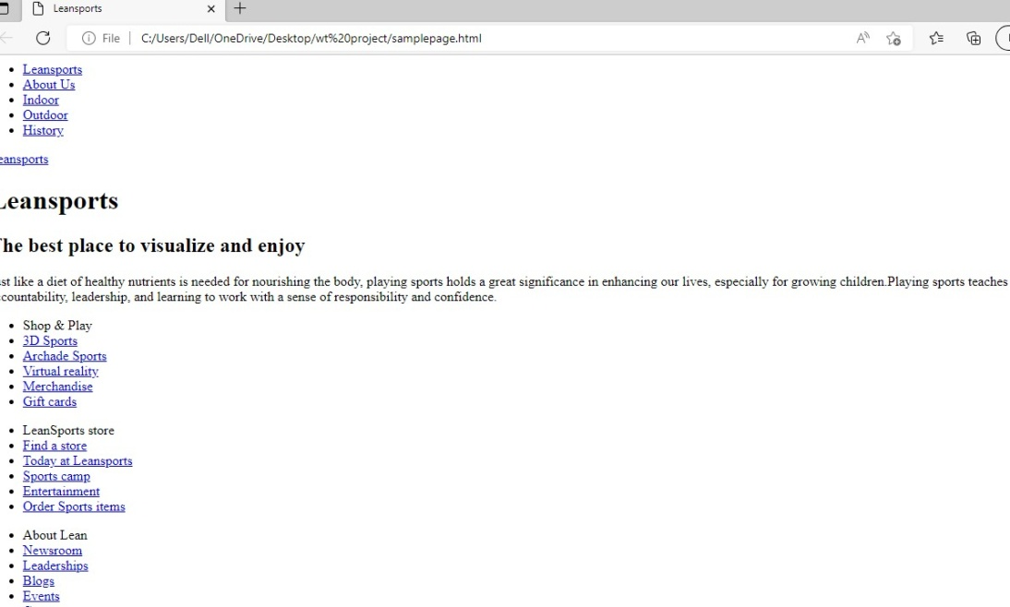

The above picture depicts the project only with the implementation of HTML.

The Main page is divided into header and footer and required css properties are implemented.

The header part contains navigation bar and description of the website.

The footer part contains grid system which is implemented using bootstrap..

In the project various selectors are applied,about us page consists of form which is build using various form controls.

### Learning after Internship

During the internship I learnt to develop a basic website using html,css.I learnt about working of github . I had a lot of doubts and got stuck at numerous places but by implementing concepts I learnt in project helped me to boost my confidence.Got exposure to various components of CSS. Thanks to Kaashiv infotech, I gained so much more in- depth knowledge of technical skills and personal skills This project helped me gather theoretical and practical knowledge about HTML5, CSS, Github.

### CONCLUSION

Electronic purchasing has become more important as a result of the Internet's emergence as a key resource in contemporary business, both from an entrepreneur's and a customer's perspective. Electronic shopping creates new business prospects for the entrepreneur and allows consumers to compare prices. This project helps in understanding the creation of an interactive web page and the technologies used to implement it.Only frontend technologies are used to develop the project the consumer can log in, with his information such as his email ,twitter and password.

### BIBLIOGRAPHY

* 1. Trevor Burnham. ***Async JavaScript***. The Pragmatic Bookshelf, Raleigh, NC and Dallas, TX, 2012.
  2. Jon Duckett. ***HTML and CSS: Design and Build Websites***. John Wiley & Sons, New York, NY, 2-11.
  3. Andrew Hunt and David Thomas. ***The Pragmatic Programmer: From Journeyman to Master***. Addison-Wesley, Reading, MA, 2000.
  4. Christophe Porteneuve. ***Pragmatic Guide to JavaScript***. The Pragmatic Bookshelf, Raleigh, NC and Dallas, TX, 2010.
  5. Jeffrey Zeldman. ***Designing with Web Standards***. New Riders Press, Upper Saddle River, NJ, 2009.